**Lab6.1: Using MySQL with PHP**

**6.3. . Examples in the lecture slides**

Step 1: Create table

Step 2: Insert table

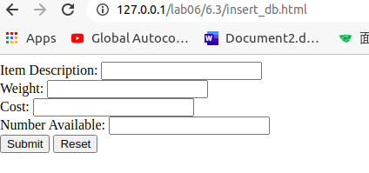

Step 3: Display list of products

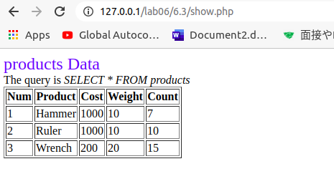

Step 4: Search Product

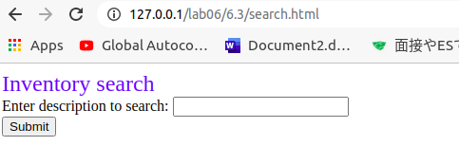

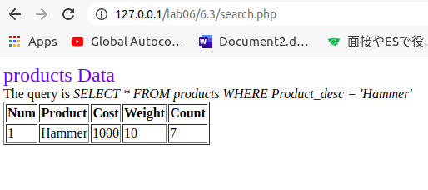

Step 5: Update Product



6.5. Category Administration

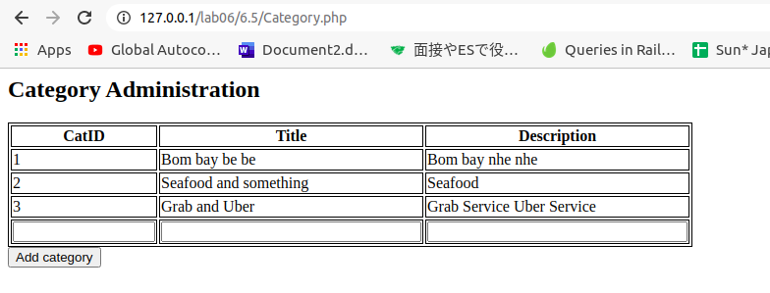

6.6. Business Registration

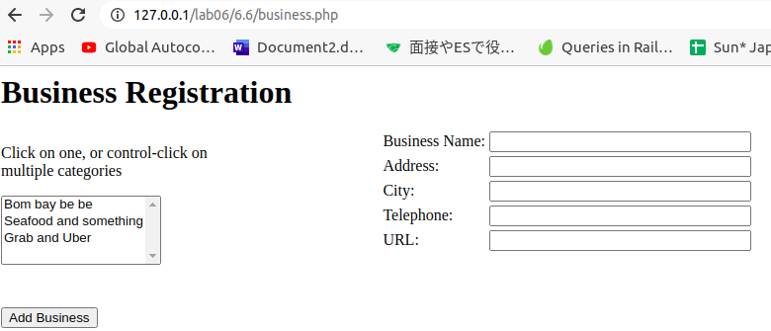

6.7. Business listing page

